**World Quant University**

**Statistics Final Project**

Nikolas Lippmann Pareschi - [nikolaslippmann@gmail.com](mailto:nikolaslippmann@gmail.com)

I chose AMD and INTEL (INTC is the Nasdaq code for INTEL) from Nasdaq and then downloaded 2 years of price from yahoo (AMD sheet and INTC sheet). I have chosen AMD and INTEL because they are direct competitors so it would be interesting to make an inference using data to see if one stock is outperforming the other maybe due to winning the direct competition. Therefore, this is the hypothesis that we want to test:

H1 -> The mean daily returns of AMD and INTEL are different.

The null hypothesis is:

Ho -> The mean daily returns of AMD and INTEL are equal.

In AMD and INTC sheets I calculated the daily returns. I used the adjusted close prices because those prices are adjusted for splits and mergers. Now to proceed in our analysis we need a sampling method to pick 30 random returns from each daily return series.

I have done that in the sheets SAMPLE AMD and SAMPLE INTC. I used in the column A the function: RANDBETWEEN($I$2,$I$506) +I2/505. The I column have numbers from 1 to 505. Therefore, we avoid repetition. Next we use in the B column the rank function so we have an unique order. We then use the VLOOKUP function in column D to match each daily return value with each random ranked day in B column.

Initially I have collected only 30 random daily returns and the mean sample and standard deviation sample of these sheets considers N = 30. Afterwards in our analysis we tried to analyze bigger samples to see if we would get different results.

But, before proceeding into our analysis we must first check the descriptive statistics:

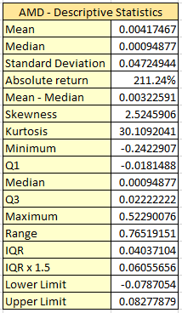 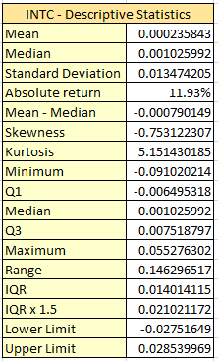

Both distributions are not symmetric, we have the median different from the mean. Both distributions present skewness also and are not symmetric as a normal distribution would be. Both distributions have high kurtosis (kurtosis > 3), differently from what normal distribution would present. These facts indicate that it is safer to make our analysis considering the Interquartile Range approach.

We have plotted the histogram also for both stocks:

We can observe some outliers in the histogram graphs, AMD had in fact a daily return of 52,29%. This return is 10.97 standard deviations above the medium. It is another good argument to not consider the normal distribution.

Using interquartile analysis and the box plot we can see several outliers in the AMD daily returns distribution and in the INTEL daily returns distribution:

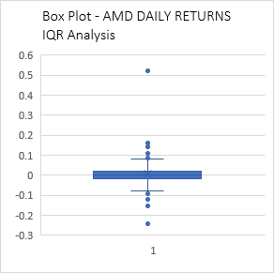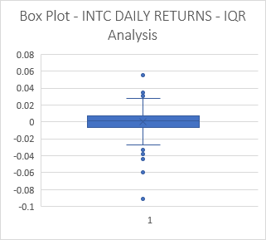

In our Interquartile analysis it was considered an outlier for AMD every daily return below -0.0787054 and above 0.08277879. It was considered an outlier for INTC every daily return below -0.02751649 and above 0.028539969. These values were calculated in AMD – Descriptive Statistics and INTL – Descriptive Statistics sheets.

We then proceed to test our hypothesis H1- The mean daily returns of AMD and INTEL are different. As the:

* The samples are obtained using simple random sampling or through a randomized experiment.
* The samples are independent.
* The populations from which the samples are drawn are normally distributed or the sample sizes are large (n1> 30 and n2> 30).
* For each sample, the sample size is no more than 5% of the population size.

we performed a T-test for two samples assuming unequal variances. Actually, we need to say that using 2 years of data and a n = 30 each sample will be a little higher than 5% of the population size. We used Data Analysis in excel:

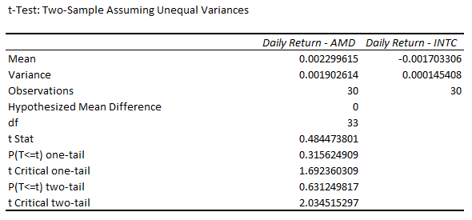

The t Stat was not above the Critical two-tail test and the p-value for the two-tail test was not under the desired 0.05 level. Therefore, we cannot conclude that AMD or INTC is outperforming its direct competitor. We reject H1 and we are not able to reject that AMD and INTC have the same daily returns (accept Ho).

Nevertheless, it is interesting to notice that AMD really outperformed INTC considering all the data from the last 2 years:

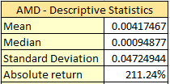 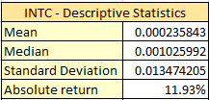

So I performed several t-tests with different random sampling to know if I just got an outlier. It was not the case. This is another test with similar results:

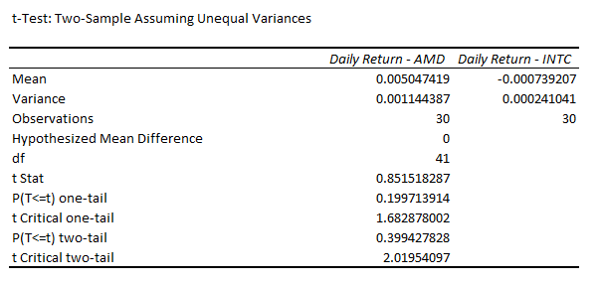

Then I thought that maybe 30 was a small number for the random sample, so I performed the same test for n = 100 and got similar results:

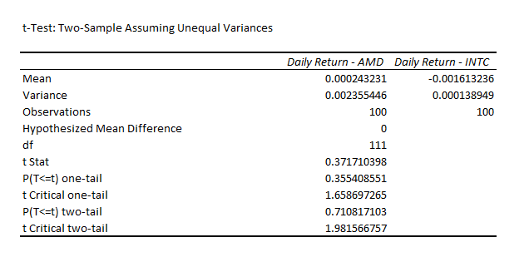

Last but not least, I tried to obey the 5% rule. Unsuccessful again:

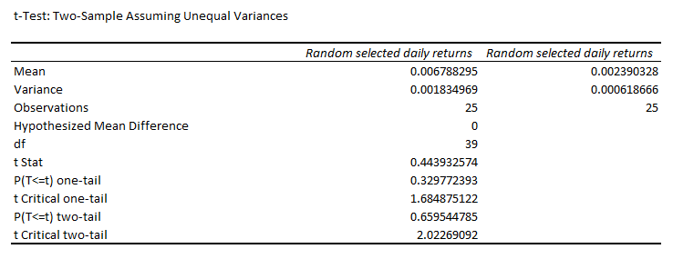

So it was clear that we cannot choose INTC nor AMD using inferential statistics, at least in these 2 years. An interesting fact was that the common knowledge was that Intel was winning the competition in these years. But the descriptive statistics said the opposite. AMD shares crushed INTEL shares. Maybe the market had already considered the I-7/ I-5 chipset advantage in the years before our tests. We rejected that AMD and INTC had different daily means in our hypothesis testing.